使用SDK: Kinect for Windows SDK v2.0 public preview
这次说说这骨骼帧的获取。嗯，Kinect买来就为这个啊。不然其他数据，买其他产品就行了，Kinect的卖点也是这个。
先看看这次支持的骨骼关节:
[cpp] view plaincopy
- enum _JointType
- {
- JointType_SpineBase = 0,
- JointType_SpineMid = 1,
- JointType_Neck = 2,
- JointType_Head = 3,
- JointType_ShoulderLeft = 4,
- JointType_ElbowLeft = 5,
- JointType_WristLeft = 6,
- JointType_HandLeft = 7,
- JointType_ShoulderRight = 8,
- JointType_ElbowRight = 9,
- JointType_WristRight = 10,
- JointType_HandRight = 11,
- JointType_HipLeft = 12,
- JointType_KneeLeft = 13,
- JointType_AnkleLeft = 14,
- JointType_FootLeft = 15,
- JointType_HipRight = 16,
- JointType_KneeRight = 17,
- JointType_AnkleRight = 18,
- JointType_FootRight = 19,
- JointType_SpineShoulder = 20,
- JointType_HandTipLeft = 21,
- JointType_ThumbLeft = 22,
- JointType_HandTipRight = 23,
- JointType_ThumbRight = 24,
- JointType_Count = ( JointType_ThumbRight + 1 )
- } ;
支持这25个关节点，不排除会增加的可能，毕竟近景可以分辨十指。
每个关节的状态用这个结构体描述:
[cpp] view plaincopy
- typedef struct _Joint
- {
- JointType JointType;
- CameraSpacePoint Position;
- TrackingState TrackingState;
- } Joint;
JointType就是之前的关节编号，Position是Kinect的相机空间坐标，是三维的。TrackingState是目前关节的追踪状态，
有: 未追踪(0)，位置是推测的(1)，位置是追踪的(2)

值得说明的是这次C++的SDK也提供了判断手的状态：
[cpp] view plaincopy
- enum _HandState
- {
- HandState_Unknown = 0,
- HandState_NotTracked = 1,
- HandState_Open = 2,
- HandState_Closed = 3,
- HandState_Lasso = 4
- } ;
有:未知(0)，未追踪(1)，摊开(2)，握拳(3)以及Lasso(4)，Lasso不知道怎么翻译，大概就是处于摊开与握拳之间的状态，
比如:或者甚至这样都能称为Lasso。

使用方法和之前的差不多，说说不同的:
[cpp] view plaincopy
- IBody* ppBodies[BODY_COUNT] = {0};

- if (SUCCEEDED(hr))
- {
- hr = pBodyFrame->GetAndRefreshBodyData(BODY_COUNT, ppBodies);
- }

这样获取6个IBody接口，用完了记得释放，一个循环释放完

每个接口使用类似下面的代码获取数据:
[cpp] view plaincopy
- for (int i = 0; i < nBodyCount; ++i)
- {
- IBody* pBody = ppBodies[i];
- if (pBody)
- {
- BOOLEAN bTracked = false;
- hr = pBody->get_IsTracked(&bTracked);

- if (SUCCEEDED(hr) && bTracked)
- {
- Joint joints[JointType_Count];
- HandState leftHandState = HandState_Unknown;
- HandState rightHandState = HandState_Unknown;

- pBody->get_HandLeftState(&leftHandState);
- pBody->get_HandRightState(&rightHandState);

- hr = pBody->GetJoints(_countof(joints), joints);
- if (SUCCEEDED(hr))
- {
- // XXXXXXXX
- }
- }
- }
代码很简单，从方法名字就能看出来。这里的可视化方法是用微软提供SDK例子里面的方法，
大概就是相连的关节使用直线连起来之类的，这部分代码相当无聊，有Direct2D基础的同学可以无视，详细请看范例。
效果如下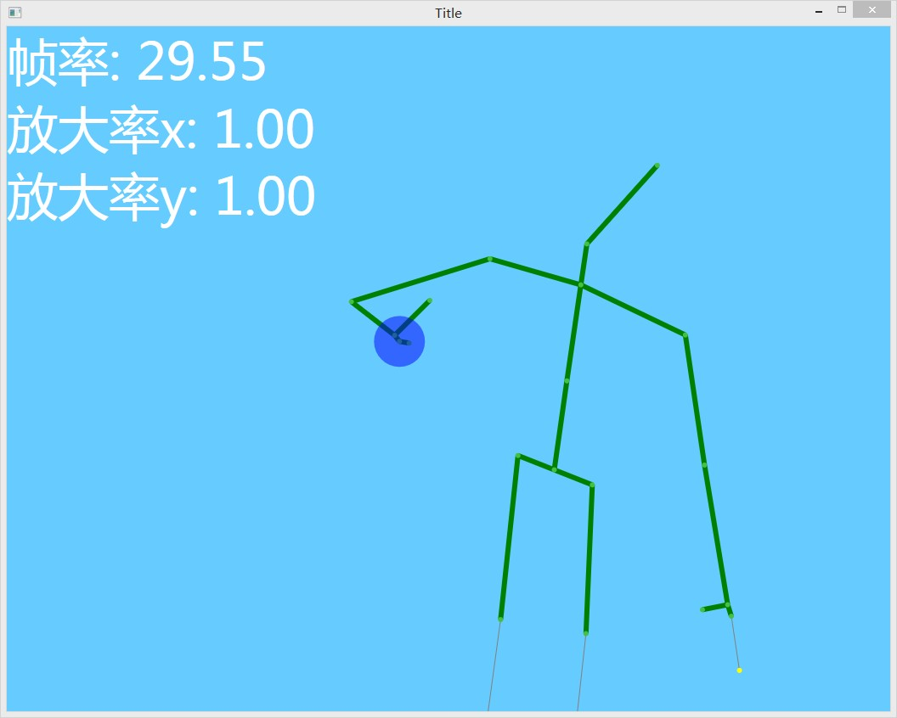
好了，其实之前的例子SDK提供的例子多少有，这里自然要给个原创的东西(当然创意不是原创的)。
看到标题的同学大概也能猜到了，那就是《攻壳机动队 S.A.C》(Ghost In The Shell: Stand Alone Complex)里面出现的一个人物，这个人物出场使用一个图标挡住了脸：
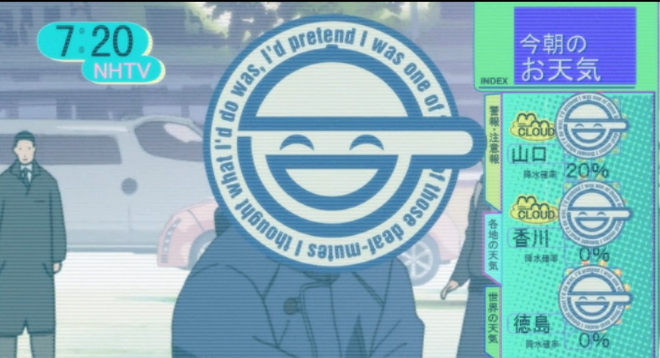
这里我们就要实现这个效果，算是一个实时打码的软件吧。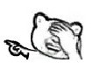
这里，我们的那个文字也要像原作一样旋转，为了保证流程，所以我们这次图像API选择的D2D 1.1(能够等在垂直同步)。
D2D 1.1的初始化，说实话，我都不记得，
要用D2D 1.1时，复制过来即可，毕竟不是考试

那么怎么实现那个图标呢，您可是使用图片。但是作为程序猿，使用代码即时生成是一个不错的选择。
Direct2D提供了一个硬件加速的几何体渲染接口，非常方便。旋转的文字渲染需要DirectWrite + Direct2D，学习的范围不在这里，
详细请看范例。

至于这个图标的几何形状怎么表示，当然用目测。。。这是不现实的，我在其他地方找到了一个笑面男的SVG图像，代码如下：
[html] view plaincopy
- <?xml version="1.0" encoding="utf-8"?>

- <svg xmlns="http://www.w3.org/2000/svg" xmlns:xlink="http://www.w3.org/1999/xlink" viewBox="-160 -160 360 320">
- <path id="f" d="m123,0a123,123 0,0 1-246,0a123,123 0,0 1 246,0"/>
- <g fill="#057">
- <circle r="160"/>
- <circle r="150" fill="#fff"/>
- <text font-size="28" font-stretch="condensed" font-family="Impact">
- <animateTransform type="rotate" from="360 0 0" to="0 0 0" dur="10s" attributeName="transform" repeatCount="indefinite"/>
- <textPath xlink:href="#f">I thought what I'd do was, I'd pretend I was one of those deaf-mutes</textPath>
- </text>
- <circle r="115"/>
- <circle r="95" fill="#fff"/>
- <path d="m-8-119h16 l2,5h-20z"/>
- <circle cx="160" cy="0" r="40"/>
- <path d="m-95-20v-20h255a40,40 0,0 1 0,80h-55v-20z"/>
- <path d="m-85 0a85,85 0,0 0 170,0h-20a65,65 0,0 1-130,0z"/>
- <path d="m-65 20v20h140v-20z"/>
- <path d="m-115-20v10h25v30h250a20,20 0,0 0 0,-40z" fill="#fff"/>
- <path d="m-20 10c-17-14-27-14-44 0 6-25 37-25 44 0z"/>
- <path d="m60 10c-17-14-27-14-44 0 6-25 37-25 44 0z"/>
- </g>
- </svg>
现在根据这个代码，可以大概写出下面的代码，部分坐标经过了本人的微调。
[cpp] view plaincopy
- // 创建笑面男相关
- HRESULT ImageRenderer::CreateLaughingMan(){
- // 基本半径
- const FLOAT BASE_RADIUS = 135.f;

- HRESULT hr = S_OK;
- IDWriteTextFormat* pImpactFormat = nullptr;
- // 创建Impact文本格式
- hr = m_pDWriteFactory->CreateTextFormat(
- L"Impact",
- nullptr,
- DWRITE_FONT_WEIGHT_NORMAL,
- DWRITE_FONT_STYLE_NORMAL,
- DWRITE_FONT_STRETCH_CONDENSED,
- 41.f/96.f*72.f,
- L"",
- &pImpactFormat
- );

- // 创建文本布局
- if (SUCCEEDED(hr)){
- pImpactFormat->SetWordWrapping(DWRITE_WORD_WRAPPING_NO_WRAP);
- WCHAR* text = L"I thought what I'd do was, I'd pretend I was one of those deaf-mutes";
- auto length = wcslen(text);
- hr = m_pDWriteFactory->CreateTextLayout(text, length, pImpactFormat, BASE_RADIUS, BASE_RADIUS, &m_pTextLayoutLaughingMan);
- }
- // 创建文本几何路径: 一个圆
- if (SUCCEEDED(hr)){
- D2D1_ELLIPSE ellipse;
- ellipse.point.x = 0.f;
- ellipse.point.y = 0.f;
- ellipse.radiusX = BASE_RADIUS;
- ellipse.radiusY = BASE_RADIUS;
- hr = m_pD2DFactory->CreateEllipseGeometry(&ellipse, &m_pTextAnimationPath);
- }
- // 笑面男路径
- if (SUCCEEDED(hr)){
- hr = m_pD2DFactory->CreatePathGeometry(&m_pLaughingManGeometryBlue);
- // 画线
- ID2D1GeometrySink* pSink = nullptr;
- if (SUCCEEDED(hr)){
- hr = m_pLaughingManGeometryBlue->Open(&pSink);
- }
- if (SUCCEEDED(hr)){
- auto nowPoint = D2D1::Point2F();
- pSink->SetFillMode(D2D1_FILL_MODE_WINDING);
- D2D1_ARC_SEGMENT arc;
- D2D1_BEZIER_SEGMENT bezier;
- arc.rotationAngle = 0.f;
- // <path d="m-8-119h16 l2,5h-20z"/>
- nowPoint.x = -8.f; nowPoint.y = -124.f;
- pSink->BeginFigure(nowPoint, D2D1_FIGURE_BEGIN_FILLED);
- nowPoint.x += 16.f;
- pSink->AddLine(nowPoint);
- nowPoint.x += 2.f; nowPoint.y += 5.f;
- pSink->AddLine(nowPoint);
- nowPoint.x -= 20.f;
- pSink->AddLine(nowPoint);
- pSink->EndFigure(D2D1_FIGURE_END_CLOSED);
- // <path d = "m-95-20v-20h255a40,40 0,0 1 0,80h-55v-20z" / >
- nowPoint.x = -105.f; nowPoint.y = -20.f;
- pSink->BeginFigure(nowPoint, D2D1_FIGURE_BEGIN_FILLED);
- nowPoint.y -= 20.f;
- pSink->AddLine(nowPoint);
- nowPoint.x += 270.f;
- pSink->AddLine(nowPoint);
- nowPoint.y += 80.f;
- arc.size.height = 40.f;
- arc.size.width = 40.f;
- arc.sweepDirection = D2D1_SWEEP_DIRECTION_CLOCKWISE;
- arc.point = nowPoint;
- arc.arcSize = D2D1_ARC_SIZE_SMALL;
- pSink->AddArc(&arc);
- nowPoint.x -= 55.f;
- pSink->AddLine(nowPoint);
- nowPoint.y -= 20.f;
- pSink->AddLine(nowPoint);
- nowPoint.x += 55.f;
- pSink->AddLine(nowPoint);
- nowPoint.y -= 40.f;
- arc.size.height = 20.f;
- arc.size.width = 20.f;
- arc.sweepDirection = D2D1_SWEEP_DIRECTION_COUNTER_CLOCKWISE;
- arc.point = nowPoint;
- pSink->AddArc(&arc);
- pSink->EndFigure(D2D1_FIGURE_END_CLOSED);
- // <path d="m-85 0a85,85 0,0 0 170,0h-20a65,65 0,0 1-130,0z"/>
- nowPoint.x = -85.f; nowPoint.y= 20.f;
- pSink->BeginFigure(nowPoint, D2D1_FIGURE_BEGIN_FILLED);
- nowPoint.x += 170.f;
- arc.size.height = 90.f;
- arc.size.width = 90.f;
- arc.sweepDirection = D2D1_SWEEP_DIRECTION_COUNTER_CLOCKWISE;
- arc.arcSize = D2D1_ARC_SIZE_SMALL;
- arc.point = nowPoint;
- pSink->AddArc(&arc);
- nowPoint.x -= 20.f;
- pSink->AddLine(nowPoint);
- nowPoint.x -= 130.f;
- arc.size.height = 70.f;
- arc.size.width = 70.f;
- arc.sweepDirection = D2D1_SWEEP_DIRECTION_CLOCKWISE;
- arc.point = nowPoint;
- pSink->AddArc(&arc);
- pSink->EndFigure(D2D1_FIGURE_END_CLOSED);
- // <path d="m-65 20v20h130v-20z"/>
- nowPoint.x = -65.f; nowPoint.y = 20.f;
- pSink->BeginFigure(nowPoint, D2D1_FIGURE_BEGIN_FILLED);
- nowPoint.y += 20.f;
- pSink->AddLine(nowPoint);
- nowPoint.x += 130.f;
- pSink->AddLine(nowPoint);
- nowPoint.y -= 20.f;
- pSink->AddLine(nowPoint);
- pSink->EndFigure(D2D1_FIGURE_END_CLOSED);
- //pSink->BeginFigure(nowPoint, D2D1_FIGURE_BEGIN_FILLED);
- // <path d = "m-20 10c-17-14-27-14-44 0 6-25 37-25 44 0z" / >
- nowPoint.x = -20.f; nowPoint.y = 10.f;
- pSink->BeginFigure(nowPoint, D2D1_FIGURE_BEGIN_FILLED);
- bezier.point1.x = nowPoint.x - 17.f;
- bezier.point1.y = nowPoint.y - 14.f;
- bezier.point2.x = nowPoint.x - 27.f;
- bezier.point2.y = nowPoint.y - 14.f;
- nowPoint.x -= 44.f;
- bezier.point3 = nowPoint;
- pSink->AddBezier(&bezier);
- bezier.point1.x = nowPoint.x + 6.f;
- bezier.point1.y = nowPoint.y - 25.f;
- bezier.point2.x = nowPoint.x + 37.f;
- bezier.point2.y = nowPoint.y - 25.f;
- nowPoint.x += 44.f;
- bezier.point3 = nowPoint;
- pSink->AddBezier(&bezier);
- pSink->EndFigure(D2D1_FIGURE_END_CLOSED);
- // <path d = "m60 10c-17-14-27-14-44 0 6-25 37-25 44 0z" / >
- nowPoint.x = 60.f; nowPoint.y = 10.f;
- pSink->BeginFigure(nowPoint, D2D1_FIGURE_BEGIN_FILLED);
- bezier.point1.x = nowPoint.x - 17.f;
- bezier.point1.y = nowPoint.y - 14.f;
- bezier.point2.x = nowPoint.x - 27.f;
- bezier.point2.y = nowPoint.y - 14.f;
- nowPoint.x -= 44.f;
- bezier.point3 = nowPoint;
- pSink->AddBezier(&bezier);
- bezier.point1.x = nowPoint.x + 6.f;
- bezier.point1.y = nowPoint.y - 25.f;
- bezier.point2.x = nowPoint.x + 37.f;
- bezier.point2.y = nowPoint.y - 25.f;
- nowPoint.x += 44.f;
- bezier.point3 = nowPoint;
- pSink->AddBezier(&bezier);
- pSink->EndFigure(D2D1_FIGURE_END_CLOSED);
- hr = pSink->Close();
- }
- SafeRelease(pSink);
- }
- // 笑面男白色部分
- if (SUCCEEDED(hr)){
- hr = m_pD2DFactory->CreatePathGeometry(&m_pLaughingManGeometryWhite);
- // 画线
- ID2D1GeometrySink* pSink = nullptr;
- if (SUCCEEDED(hr)){
- hr = m_pLaughingManGeometryWhite->Open(&pSink);
- }
- if (SUCCEEDED(hr)){
- auto nowPoint = D2D1::Point2F();
- // <path d = "m-115-20v10h25v30h250a20,20 0,0 0 0,-40z" fill = "#fff" / >
- nowPoint.x = -125.f; nowPoint.y = -20.f;
- pSink->BeginFigure(nowPoint, D2D1_FIGURE_BEGIN_FILLED);
- nowPoint.y += 10.f;
- pSink->AddLine(nowPoint);
- nowPoint.x += 35.f;
- pSink->AddLine(nowPoint);
- nowPoint.y += 30.f;
- pSink->AddLine(nowPoint);
- nowPoint.x += 260.f;
- pSink->AddLine(nowPoint);
- nowPoint.y -= 40.f;
- D2D1_ARC_SEGMENT arc = { nowPoint, D2D1::SizeF(20.f, 20.f), 0.f, D2D1_SWEEP_DIRECTION_COUNTER_CLOCKWISE, D2D1_ARC_SIZE_SMALL };
- pSink->AddArc(&arc);
- pSink->EndFigure(D2D1_FIGURE_END_CLOSED);
- hr = pSink->Close();
- }
- }
- // 笑面蓝
- if (SUCCEEDED(hr)){
- hr = m_pD2DDeviceContext->CreateSolidColorBrush(D2D1::ColorF(0x005577), &m_pLaughingBlueBrush);
- }
- // 笑面白
- if (SUCCEEDED(hr)){
- hr = m_pD2DDeviceContext->CreateSolidColorBrush(D2D1::ColorF(0xFFFFFF), &m_pLaughingWhiteBrush);
- }
- SafeRelease(pImpactFormat);
- return hr;
- }
反正很蛋疼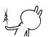

是的，我们这次使用的是D2D 1.1。之前说过，所以这里就使用轮询模式。
这里要使用彩色数据流 + 骨骼数据流，那么是否需要使用复源帧？
使用复源帧是为了保证数据同步，轮询模式下异步的效果很及时，所以这里不使用复源帧。

大致过程如下：
刷新:
获得彩色数据 -> 复制到位图
获得骨骼数据 -> 检查并更新头部位置，根据远近设置相对缩放率(实现近大远小，大致即可，不用精确)
渲染:
渲染彩色帧
渲染笑面男

Kinect2支持6人骨骼追踪，所以数据要准备6份。这样6人同时出现也能一起打码

效果如下:Kinect2获得的骨骼数据默认就已经平滑过了，不需要像1代那样设置平滑参数，也说明精度的提高。
为了模拟原作的抖动，只能自己手动模拟了。
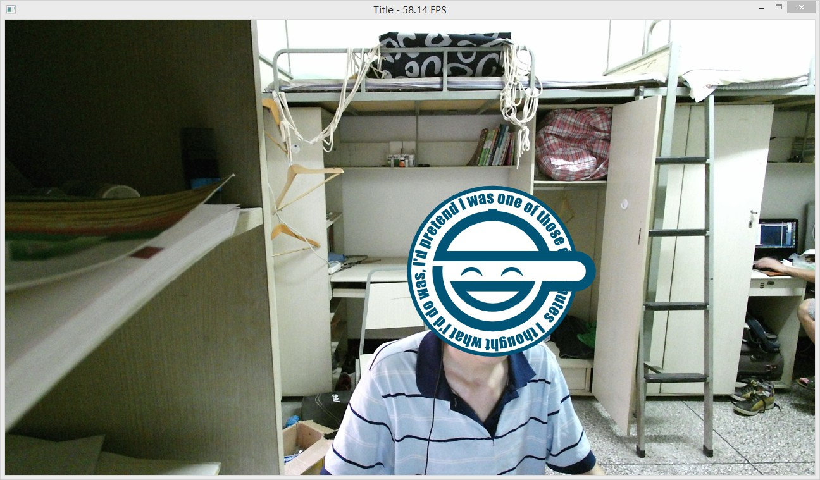

范例下载地址:点击这里
http://download.csdn.net/detail/dustpg/7678875

